Adriana Ramirez
Professor Kamerer
Comm 213

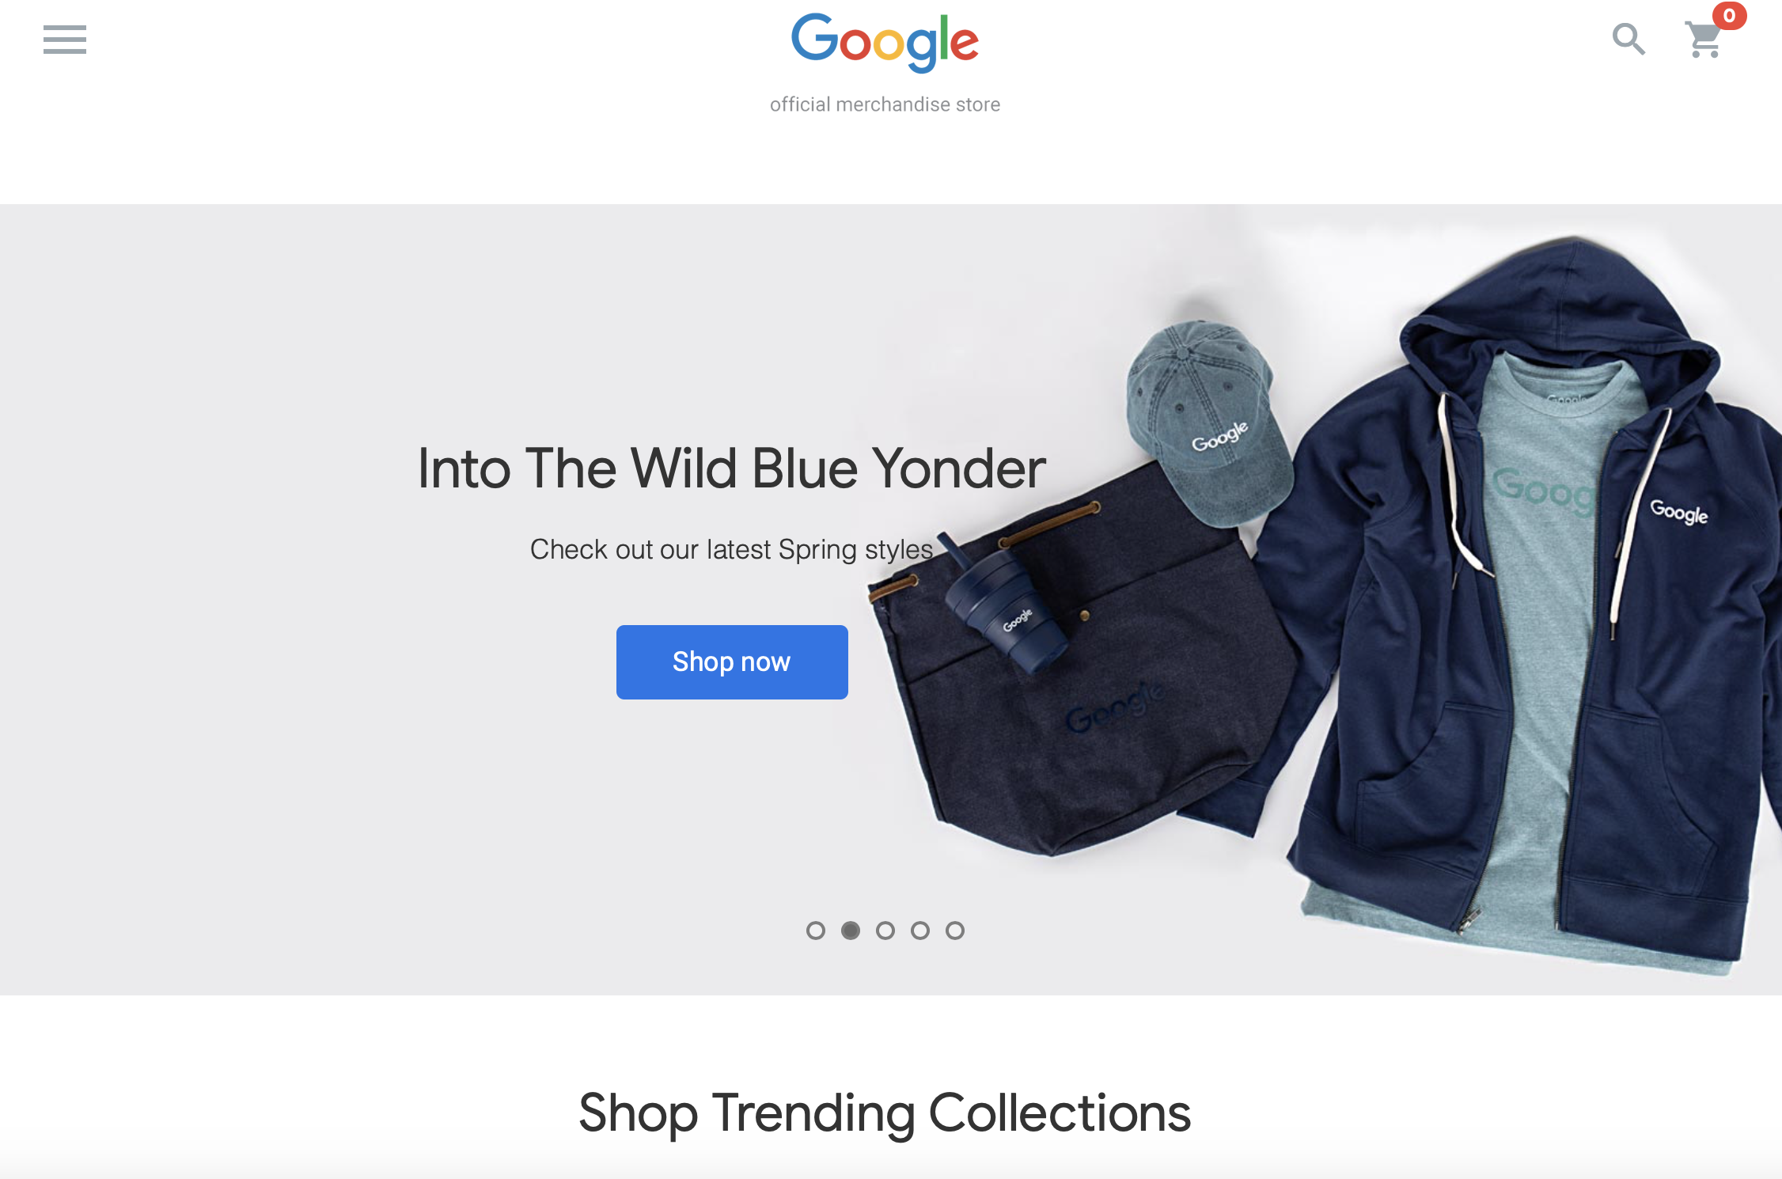
Google merchandise store home page. https://shop.googlemerchandisestore.com

Google’s merchandise store is an website that offers products for any and all Google fanatics to purchase. From clothing to stationary, users can visit the online store to make purchases of any brand offered, which are: Google, Android, Youtube, Google Cloud, and Google Maps. Below, I will be presenting an analysis Google’s merchandise store website’s performance. To do so, I will use date from Google Analytics to observe the trends within a certain time frame and look at the website’s acquisition, product performance, and more.
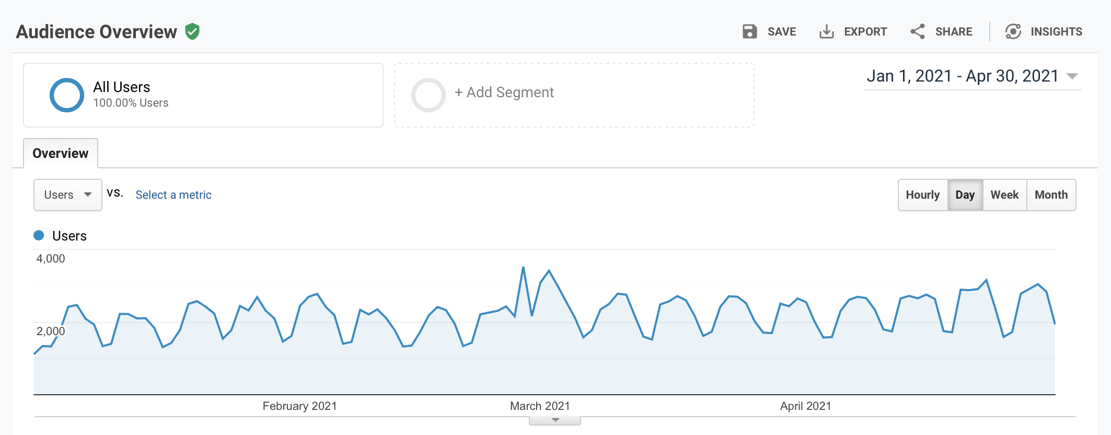Here is the overview of the user activity between January 1, 2021 and April 30, 2021.

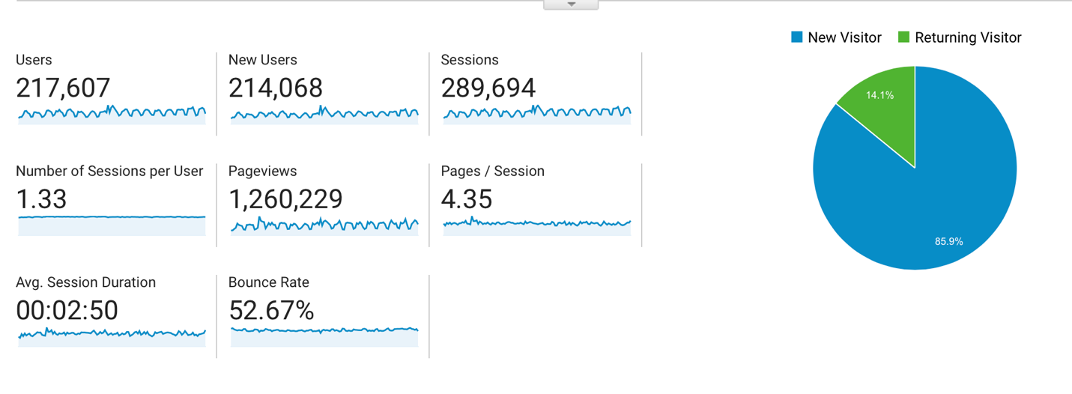
Top Level

Overall, the total amount of users was 217,607. 214,068 of them were new users with a total of 289,694 sessions; this would be around 2,414 sessions a day. There was a total of 1.33 sessions per user and total of 1,260,229 page views within the time frame. There were 4.35 pages per session, with the average session duration being 02:50 minutes. The average bounce rate in this period was 52.67%, which is actually a poor number and too high of a percentage.

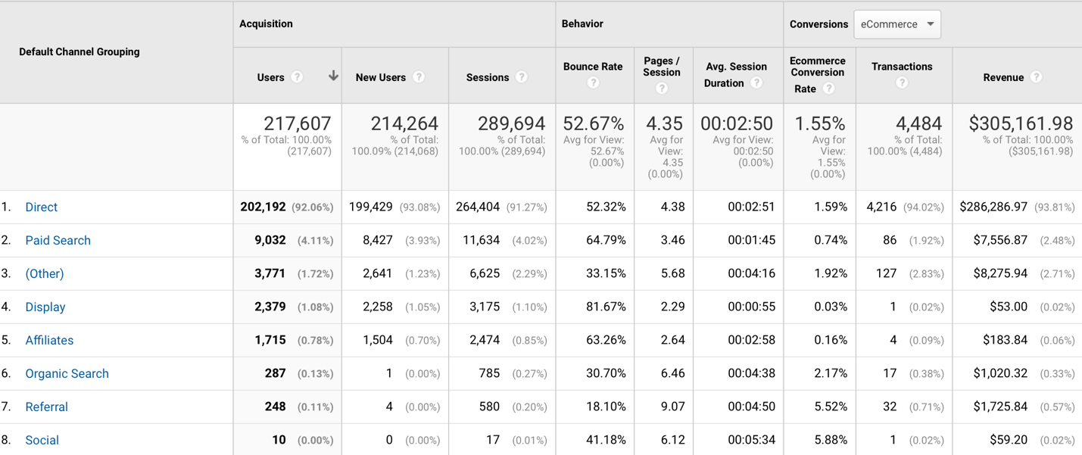
Acquisition

By looking at the first section under acquisition, we can see that the total amount of users was 217,607. Overall, the “Direct” channel appears to be the most effective channel, quantitatively, because it covers 92.06% of the total users. Direct also accounts for 93.08% of new users and 91.27% of the total sessions. Social, on the other hand, would appear to be the least effective channel, quantitatively, because it does not even account for 1% of the total users and only 0.01 % for the number of sessions.

The second category, behavior, displays the lowest bounce rate pertaining to the referral channel. A Bounce would refer to a session with only one page view. A poor bounce rate would be any percentage above 50%, according to analytics expert Avinash Kaushik, so Direct is not doing so hot anymore. The poorest performing would be Display at a staggering 81.67% bounce rate. Referral also ranks highest when it comes to the pages per session at 9.07 and also does well for sessions duration, although its 4:50 minutes is topped by social at 05:34 minutes. Referral did an overall good job in behavior instead of direct.

As for conversions in ecommerce, social has the highest conversion rate at 5.88%, but it has nearly the least amount of revenue and transactions. Direct climbs back to the top for total transactions, making up 94.02% of total transactions. It also makes up 93.81% of total revenue ($286,286.97). Both social and display channels did the worst under conversions, with only 1 transaction a2nd 0.02% in revenues.

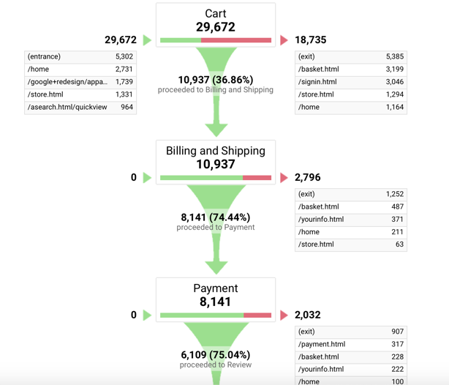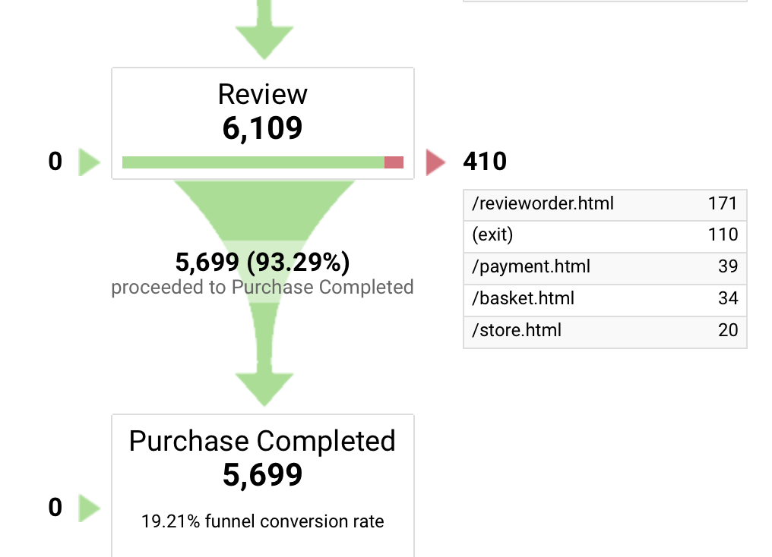
Conversion funnel for Google merchandise store

In the time frame, 29,672 users added something to their cart, but only 5,699 users actually completed their purchase. Most users fall off before billing and shipping, meaning most of them don’t attempt to begin a purchase. That would be 18,735 users out of the starting 29,672. After that, another 2,796 users don’t make it to the payment step, and then 410 more users sleave when reviewing the order, resulting in only 5,699 purchases completed (19.21% funnel conversion rate).

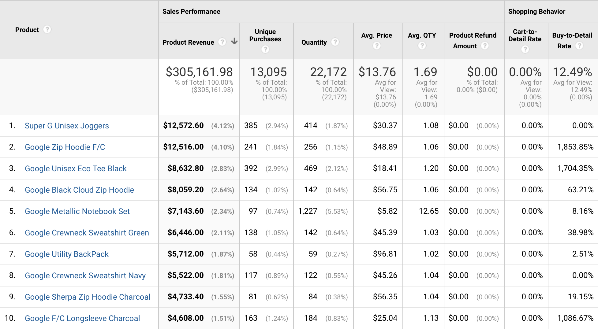
Product Performance

The product that provided the most revenue was the Super G Unisex Jogger, which totaled $12,572.60, or 4.12%, of the total product revenue. The product with the least revenue was the Google NYC Campus sticker ($1.12). Even though the joggers brought more revenue, the quantity of 414 is not the largest number. The Google Pride sticker had a total of 2,290 in quantity sold, but only provided a revenue of $1,374.45. The Google Metallic Notebook Set, ranked at #5, also has a large quantity of sales at 1,227. So, although Google clothing contributed more to the total revenue (because of the average price), miscellaneous/stationary Google products were sold in higher quantities but were just less in pricing.

It would be ideal to focus on ecommerce and maintaining exiting numbers low between adding items to the cart and completing a purchase. Making sure that the average bounce rate decreases is also important and very useful for the website. The average session duration should also be increased but this will be supported by a decrease in the bounce rate as well.

